

Measure Energy on Apertus
18.09 - 19.09.2025

Hackathon Bern

Introduction
This document describes the results of the swissAI Hackathon challenge “Measure footprint of open LLMs” which is described in detail here: https://swissai.dribdat.cc/project/44

Team Members
Agustín Herrerapicazo agustin.it@proton.me
Luis Barros luisantoniio1998@gmail.com
Stefan Aeschbacher stefan@aeschbacher.ch

Goals
To refine on the challenge we set us the
- We want to start to understand the energy consumption of Apertus
- we want to device different experiments that give us insight into different aspects of prompting
  - Prompt length
  - Response length
  - Language of the prompt
  - Subject of the prompt
- As an optional Goal we want to compare Apertus with Lllama 7B

Limitations
- Apertus is in a very early stage of development. focusing too much on the quality of the results would be “unfair”.

Infrastructure
We had two different systems at our disposition. One is a MacStudio which we could access remotely. Due to the remote access we were not able to make physical measurements during the Experiments.
Another System at our disposal was a Shuttle with an 8GB Nvidia GPU. This system was not used in any experiment.
We had the opportunity to measure the physical consumption of the MacStudio beforehand and compare it with powermetrics. We saw a difference of factor 3x to 4x between the powermetrics results and the physical measurements. As this was a very quick test, we will not elaborate on these results.

Measurement
We had different measurement options at our disposition.

Powermetrics
On the Mac Studio we used powermetrics to sample the energy of the CPU and GPU. We created a script to extract the data from the powermetrics output.

Yocto-Watt
The Yocto-Watt is a device for physically measuring the energy consumption of a device. During this hackathon challenge, we only used it to get a rough understanding of the behaviour of the machines.
https://www.yoctopuce.com/EN/products/usb-electrical-sensors/yocto-watt
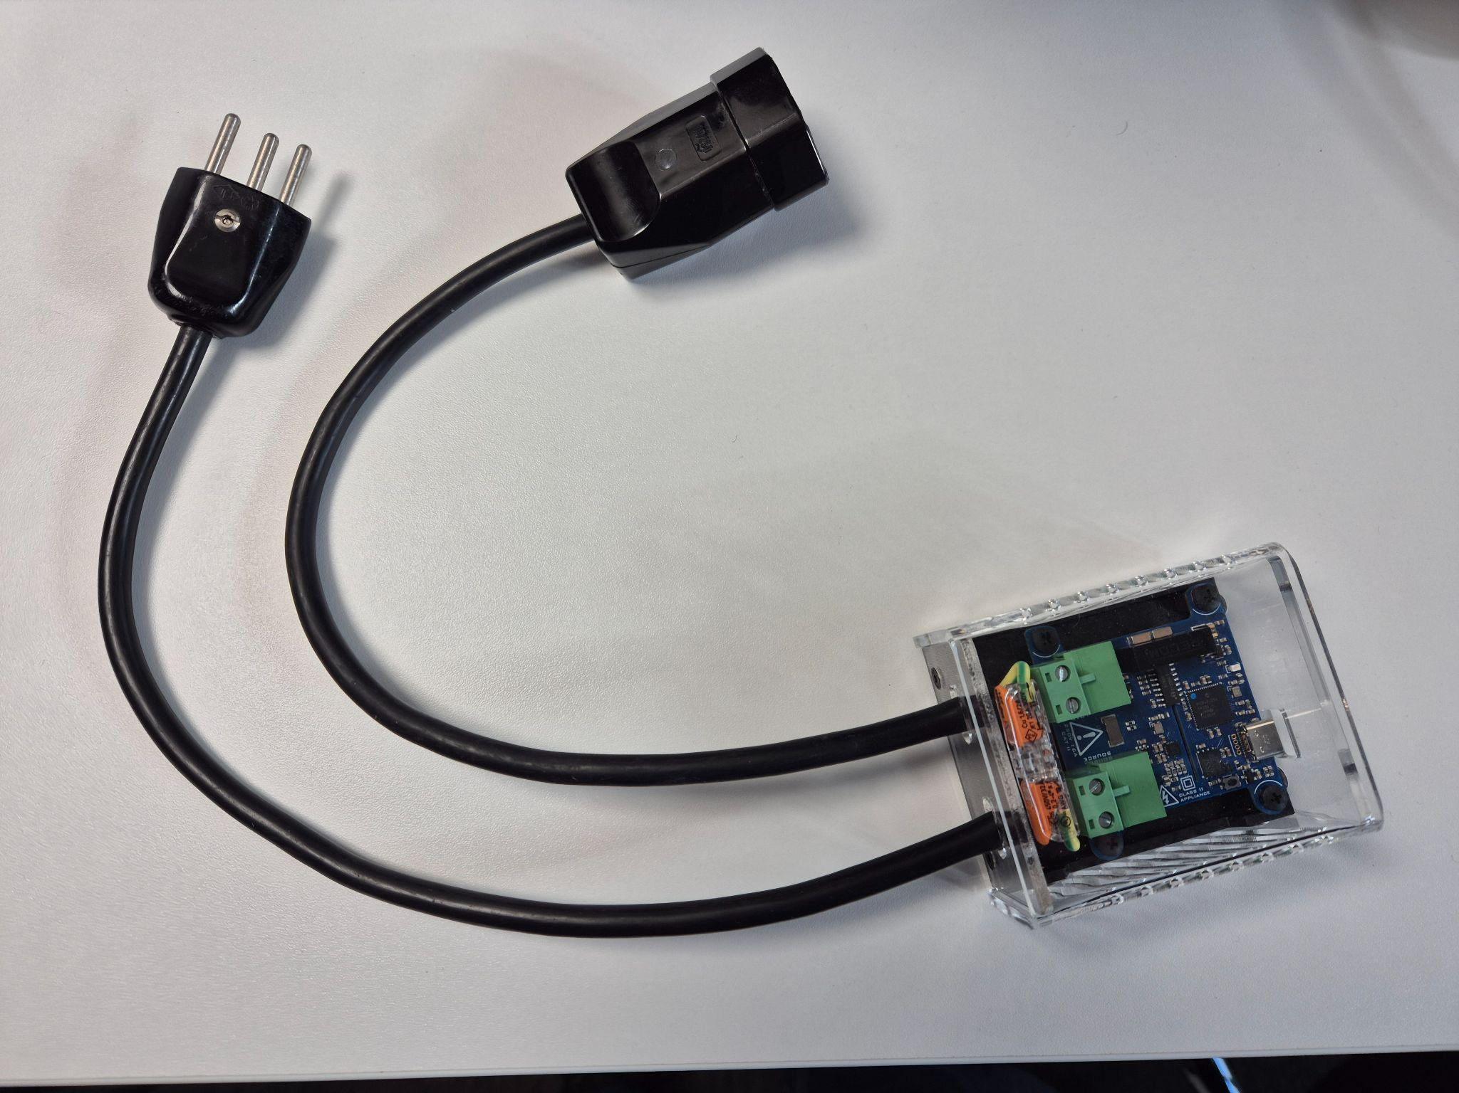

Experiments
Standard values
Sampling rate: 50ms for each sample
powermetrics prompt: powermetrics --samplers cpu_power -i 100 -n "$DURATION"

Idle consumption
At first we measured the idle consumption of the MacStudio without any load running. We did 10 runs of 30 seconds to get the idle value. We noticed several peaks in the idle consumption, so the Mac was doing some tasks in the background. This will certainly influence the measurement but due to the limited time in the hackathon we decided to live with it.
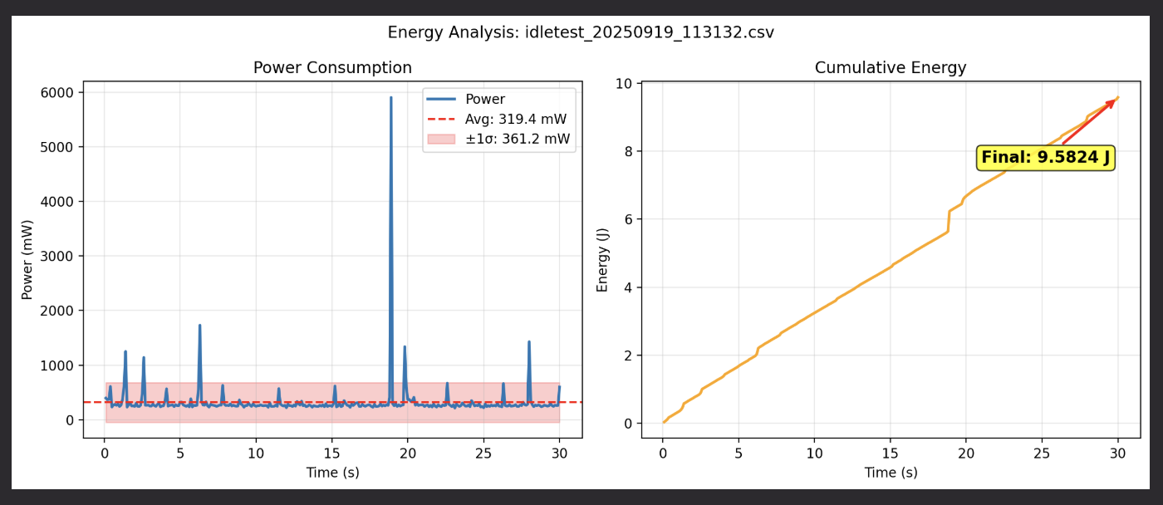

Prompt length influence on energy consumption
In this first experiment we wanted to measure the impact of prompt length and result length on the energy consumption.
Therefore we created four experiments with all permutations of prompt and result length.
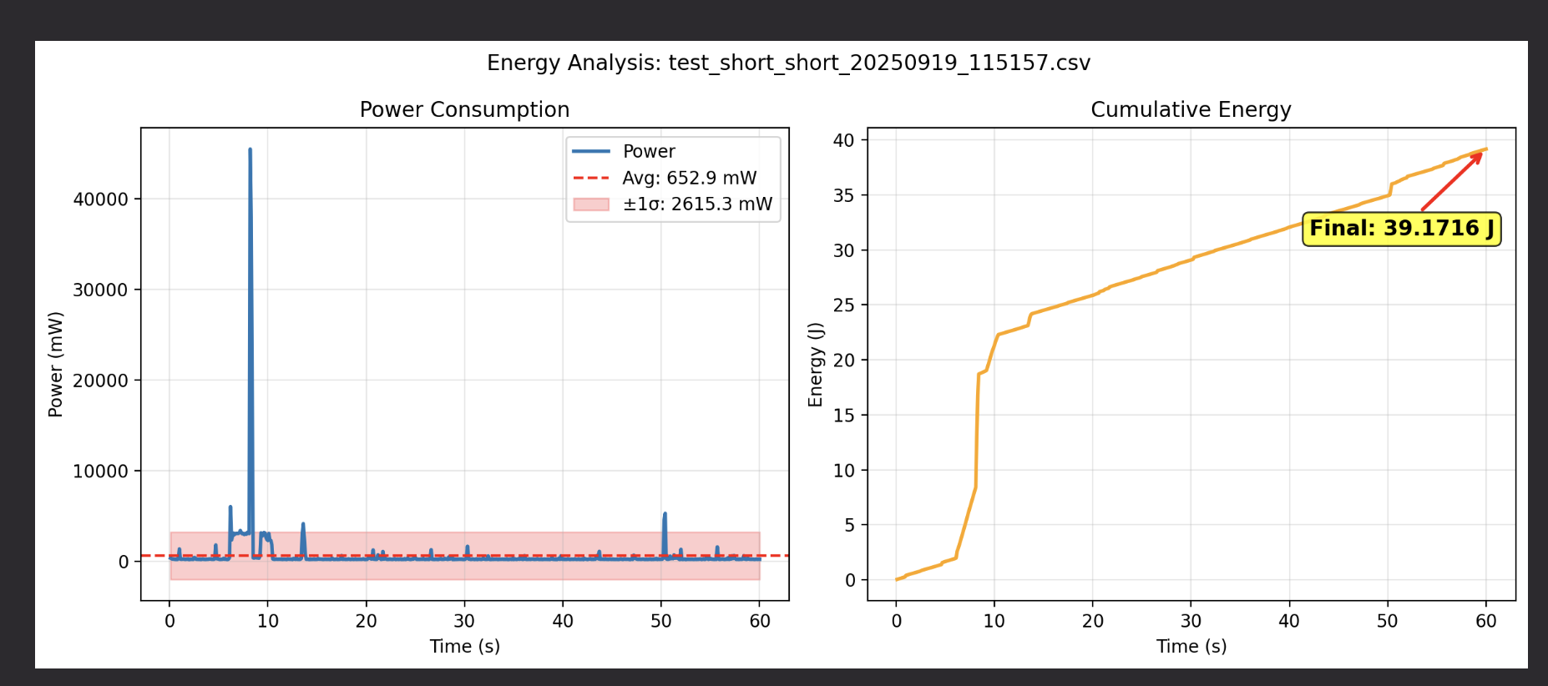
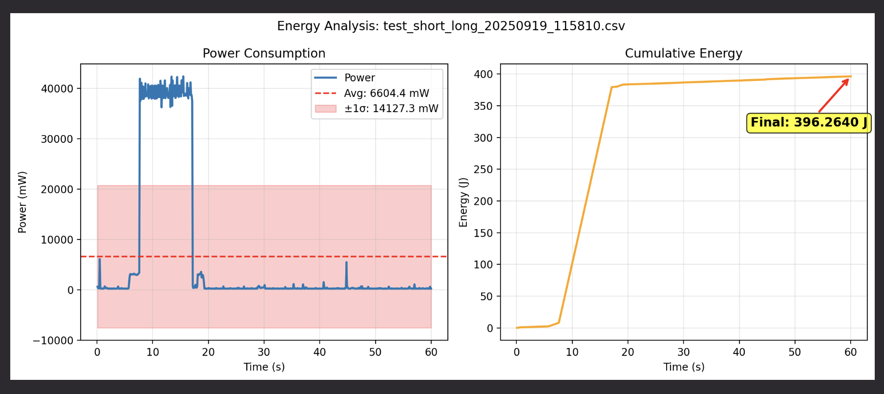
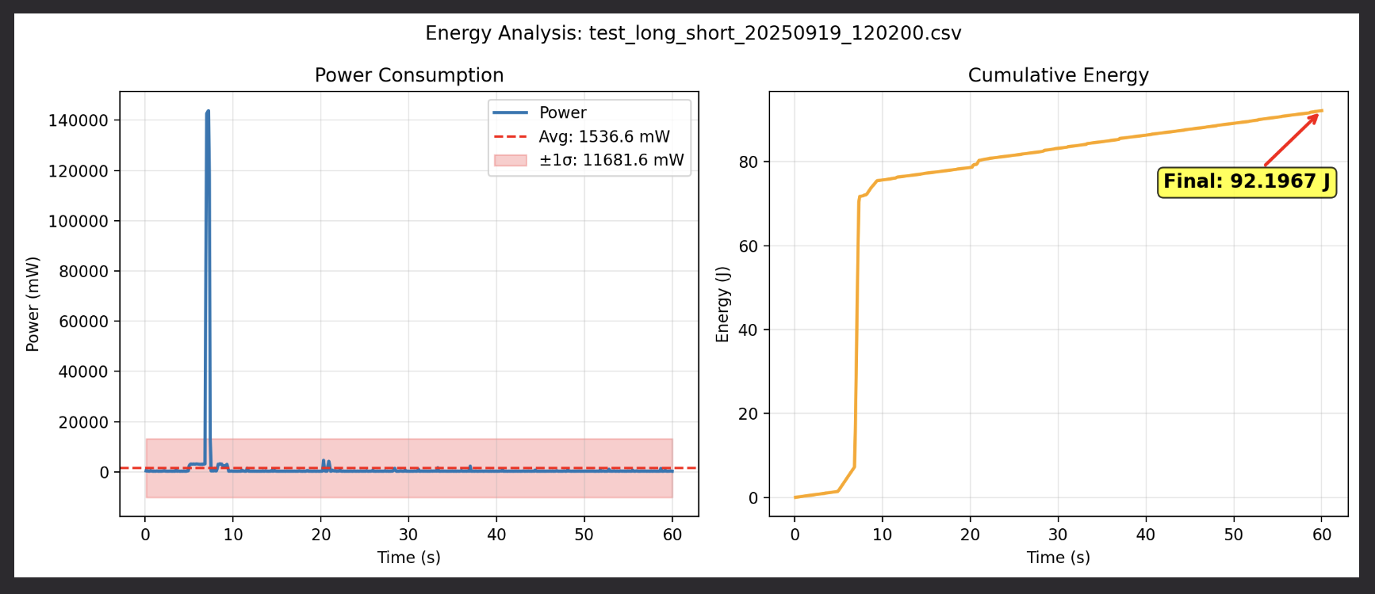
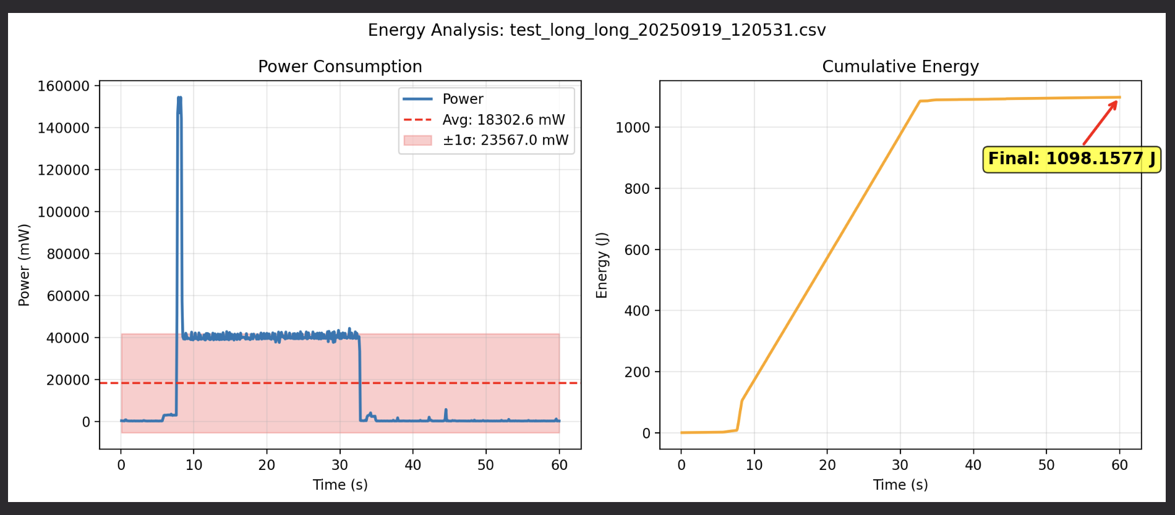

Type of prompt subject
We created different prompts that should result in short answers on different subjects. Some of the subjects were Basic Knowledge, Geography, Chemistry or Math.
Our experiments showed that the subject did not seem to matter in the energy consumption. The correlation seemed to be with the response length as in the previous experiment.

Type of prompt language
We tested four different languages, German, Spanish, Portuguese and English. Interestingly Portugese required around 20% more energy for similar length of response. This is something that could be investigated further.
Spanish:
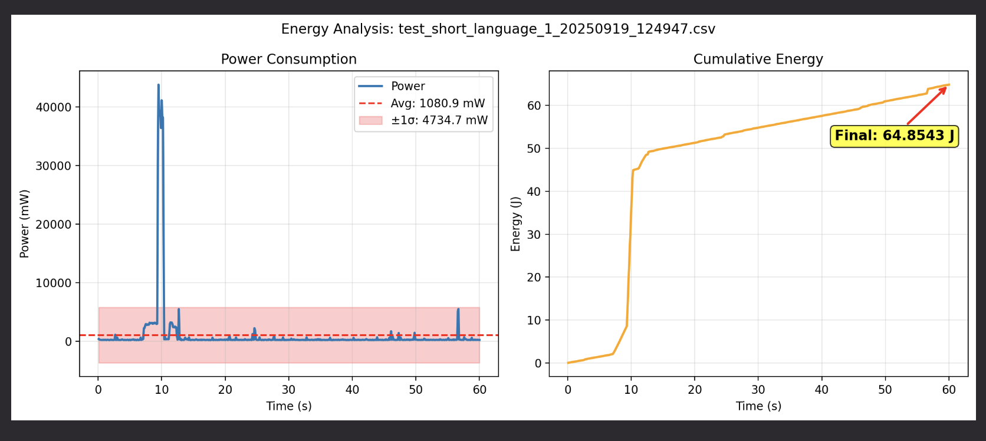
English:
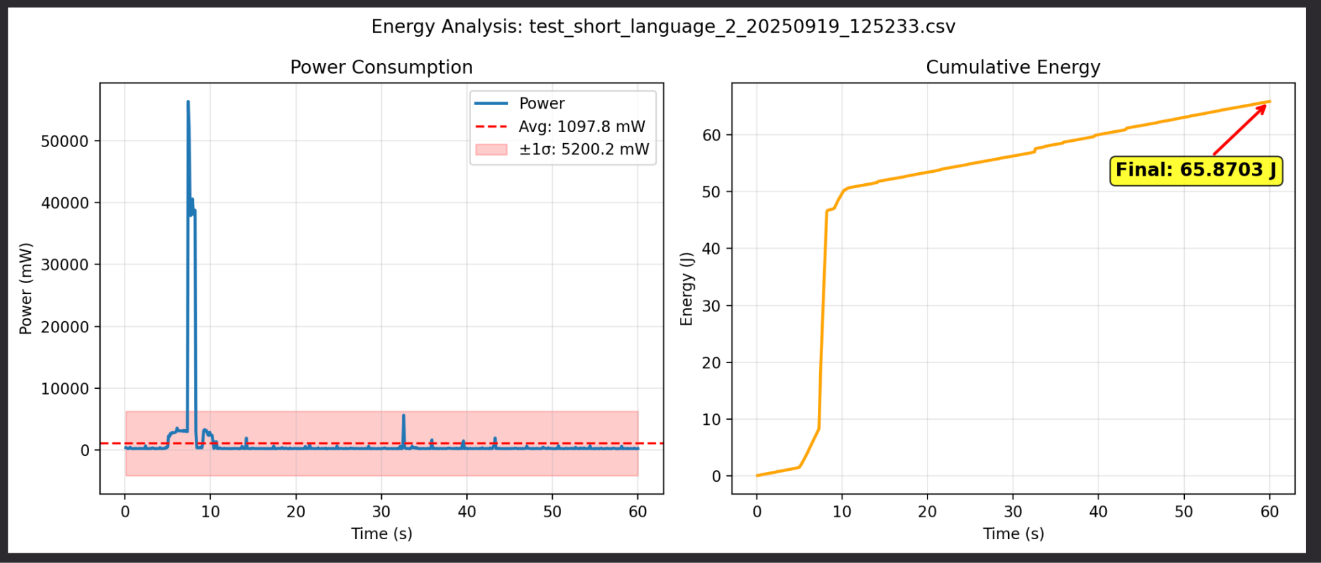

German:
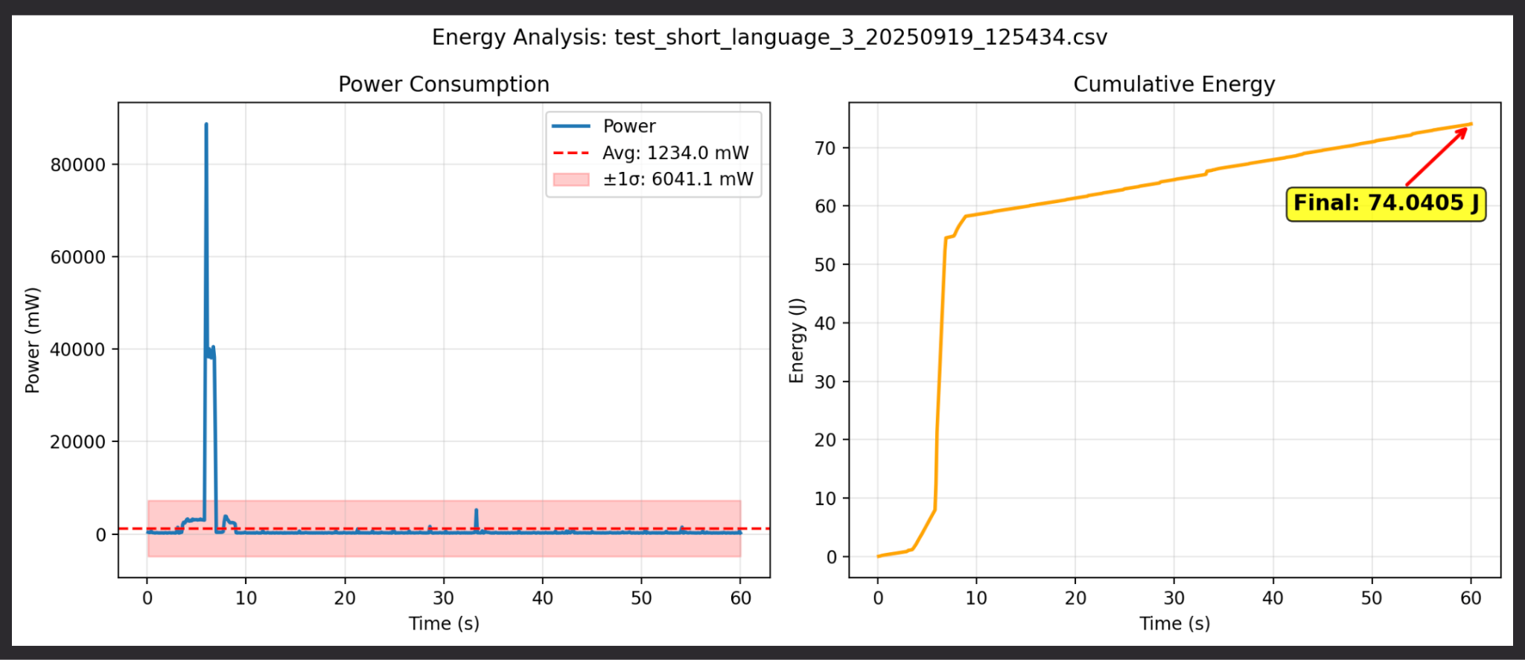
Portuguese:
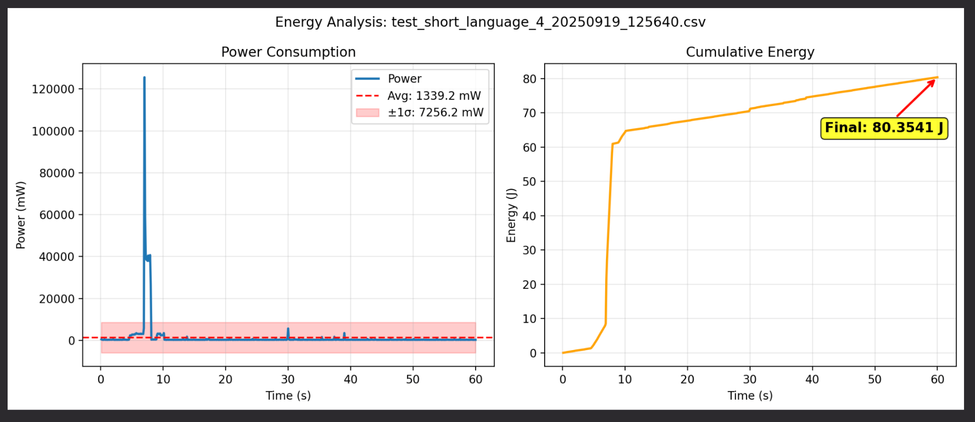

Comparison with Llama
We did some tests with short prompt short answer and short prompt and long answer between llama and apertus. There was no clear trend we could identify during the tests. The two models seem to be in the similar ballpark of energy use.

Short Long LLama:
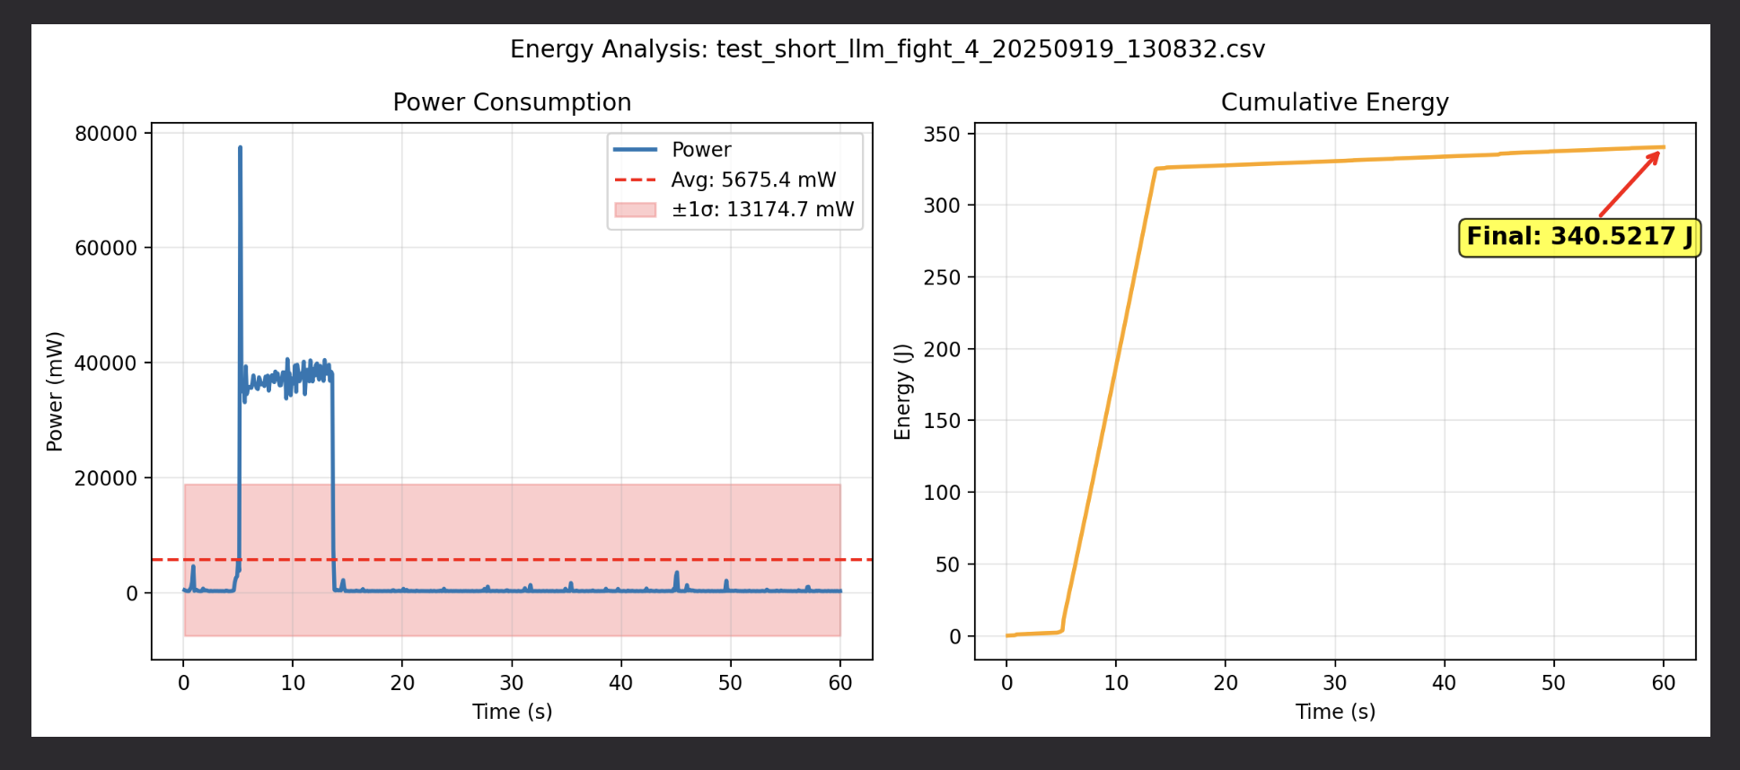
50+J difference between the same prompt length and output comparing LLama to the Apertus whereas the Apertus is the one consuming more.

Discussion

Results
The different experiments gave us some insights on the behaviour of Apertus and probably other LLMs. We can see a clear correlation between response length and energy consumption. The length of the prompt seems to play a lesser role.
The number of sample runs we could do in the available time was very low (1 for many experiments). The results should be only used as an initial indication and not as proper statistical results.

Limitations
We noticed the following effects that we were not able to address during the time of the hackathon. These effects should be analysed and reduced or better documented in another approach.
The MacStudio was not really stable at idle. We had quite a large Standard Deviation in our idle measurements. In the short time of the Hackathon, we were not able to investigate and eliminate the source.
Powermetrics adds overhead to each measurement. A sampling rate of 1/100ms results in an estimated rate of 1/120ms. Also, powermetrics generates a significant load on the CPU.
The difference between a physical measurement and the powermetrics results should be quantified more precisely to understand the impact of load measured by powermetrics on the real physical load generated by the MacStudio on the grid.

Conclusion
The Setup of the infrastructure used quite a long time. Nevertheless we had some interesting results.
One key finding is the correlation of the energy consumption with the length of the response. The prompt length itself didn’t seem to matter that much.
The comparison of llama with apertus is not conclusive and needs more work. They seem to be of similar energy consumption.
Due to the points mentioned in limitations these results have to be taken with a large grain of salt. It is not a scientific work but a proof of concept on how measurement can be performed and some indications on what results could be expected.

Sponsored by:


